COURSE SYLLABUS

MRKG 1311 (3:3:0)

PRINCIPLES OF MARKETING

Business

Business Administration Department

Technical Education Division

Lauren Gregory-- Assistant Professor, Business Administration

SOUTH PLAINS COLLEGE

SPRING 2018

MRKG 1311.151, Spring 2018
Principles of Marketing
(print for quick reference)
Online Disclaimer: This is to notify you that materials you may be accessing in chat rooms, bulletin boards or unofficial Web pages are not officially sponsored by South Plains College. The United States Constitution rights of free speech apply to all members of our community regardless of the medium used. We disclaim all liability for data, information or opinions expressed in these forums.
Instructor: | Lauren Gregory
Office: | Levelland Campus, Technology Center 104B
Office Hours: | By Appointment and posted on office door
Course Address: | http://southplainscollege.blackboard.com/
Internet Class E-mail Address: | Please use the e-mail option on the “Homepage” Course Tools control panel in Blackboard for the course.
E-mail: | lwgregory@southplainscollege.edu (Use this address for an emergency backup only.)
Telephone: | (806) 716-2249
Course Description: This is a course designed to introduce the student to the basic marketing functions, identification of consumer and organizational needs, explanation of economic, psychological, sociological, and global issues, and description and analysis of the importance of marketing research.
Course Objectives: The student will identify the marketing mix components in relation to market segmentation; explain the economic, psychological, sociological, and global factors which influence consumer and organizational decision-making processes; and interpret market research data to forecast industry trends and meet customer demands. Emphasis will be placed on utilizing the marketing model as a tool for the development of a comprehensive marketing place.
How this Course is Conducted: This course is an online course, which means that you will access course information and respond to me and/or other students through the use of the Internet. Blackboard is used to deliver and manage this course. Blackboard is a software package that was written to help manage online courses. You are encouraged to use the Blackboard e-mail for asking questions pertaining to the class.

Required Text -

Foundations of Marketing- 7th Edition; Pride/Ferrell, AND Cengage MindTap Access Code

Or, if you would like to buy the Cengage Access Code individually (no physical textbook included) that does includes the E-Book (Digital copy of textbook) you can buy it at the publishers website during the first week of class through Blackboard -

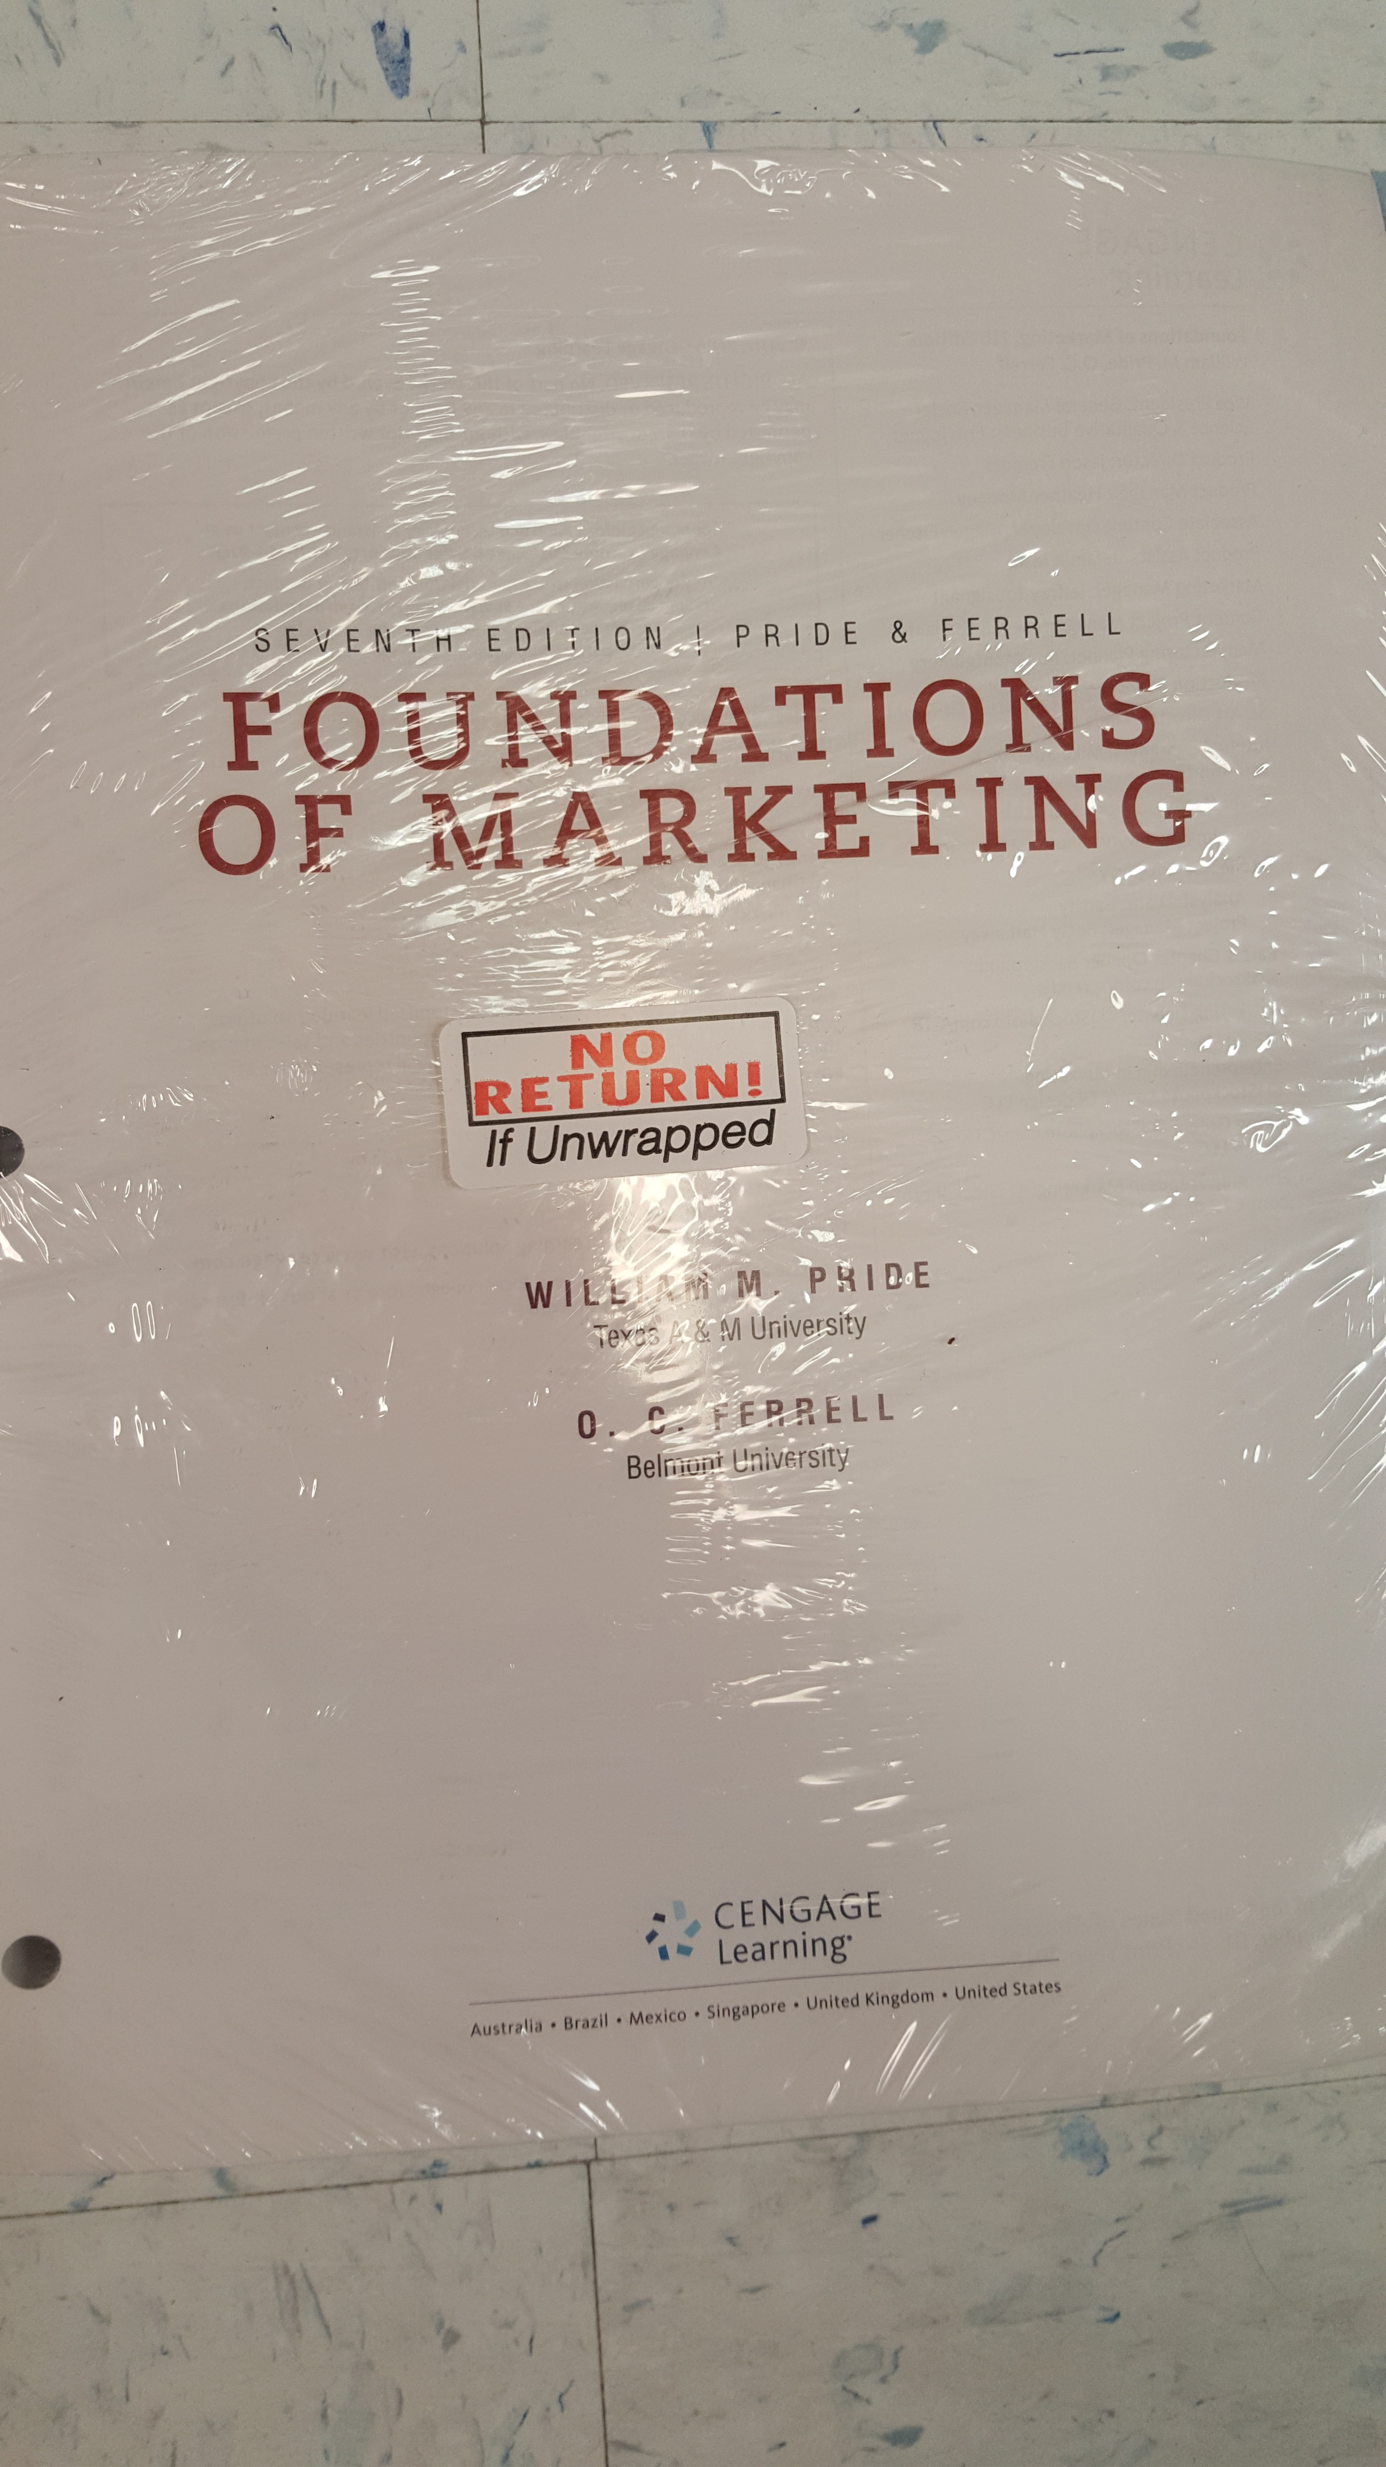

You MUST have the Cengage Mind Tap Access Code for this class, as you will complete homework/case assignments and exams through the Cengage Website.

IF buying at the Levelland or Reese bookstore, the above 2 items will come in a bundle with a loose-leaf version of the book and the access code. *Please note that the loose-leaf version is not available for buyback by the bookstore at the end of the semester.*

!!!!No matter what option you choose (loose-leaf, hardback, or E-Book)----
You MUST have a Cengage MindTap Instant Access Code to complete homework and other assignments in this online course. !!!!!
Most homework assignments/cases etc. and exams will be submitted through Cengage MindTap. Some assignments such as discussions etc. will be submitted in Blackboard.

LOGGING INTO Course: Under no circumstances are you allowed to give your User ID and/or password to anyone. If someone, besides you, is logging into this course, I will drop you immediately with an ‘F’, regardless of the reason.

Computer Requirements: I do not recommend any particular brand of computer. It is the responsibility of the student to make sure that they have the necessary computer resources and skills to take this class. Students are not required to purchase their own computer, but must have frequent regular access to one that meets specifications. There are computer labs available for student use on our Levelland, Lubbock Byron Martin ATC, and Reese Center campuses.

PLEASE make sure your computer is protected with current anti-virus software and spyware removal and prevention software. Most PC’s have Microsoft Office (Word, Excel, Access, PowerPoint, etc.), but if you do not have Office on your computer I would recommend the following website. As a student, you can get Office 365 for free. Go to the link below and register using your SPC student email address.

@students.southplainscollege.edu

https://portal.office.com/start?sku=e82ae690-a2d5-4d76-8d30-7c6e01e6022e

Check Your Internet Access
The computer you are using must be able to connect to the Internet and allow you to browse the World Wide Web. E-mail access is required to communicate with your instructor. Please go through the Check Browser options when you first access your online course in Blackboard.

To be able to participate in this online course, a student needs to have the following abilities:
• Typing and word processing skills.
• Know basic functionality of a computer and how to do basic troubleshooting.
• Know how to connect to the Internet.
• Know basics of how the Internet works and how to search and conduct research using the Internet.
• Know how to attach and open documents in an e-mail message.
• Have basic file management skills.
• Know how to save and delete documents.

Attendance Policy: Even though this is an online class, students still have to access the course on a regular basis. Minimum log in for the course is at least four (4) days per week. Additionally, you should not let more than 72 hours pass without logging in.
The Blackboard software used to manage this online course tracks student logins, tracking when and where the student has been in the course. Accessing this course on a regular basis is extremely important in order to meet the objectives of this course. Ideally, students should daily check the semester schedule, e-mail, and also check for announcements and fellow student discussions. This course is not 100% self-paced—there will be deadlines. You will feel more at ease with the materials if you stay in touch with what is going on. This course is 3 semester credit hours. For this reason, you should set aside a minimum of 6 hours per week to work on this course. One of the very first things you should do is set aside time each week to work on the class. It is very easy to put off attendance in an online course.

A STUDENT IS RESPONSIBLE FOR INITIATING THEIR OWN WITHDRAWAL, if that becomes necessary. If a student is administratively withdrawn from the class, the grade appearing on the transcript will be, at my discretion, an 'X’ or ‘F’. Administrative withdrawal may occur if the student has not logged into the course over a one (1) week period, consistently fails to meet deadlines, or if the student consistently misses logging into the course at least 4 days a week. I also reserve the right to determine excessive absences based on your progress throughout the course. If a student is not meeting requirements for the course, they will be denied access into the Blackboard course and should immediately get in touch with the instructor or withdraw from the course immediately. Being denied access into a course in Blackboard does not withdraw a student from that course—for a student to withdraw from a course, they must contact the Registrar’s Office.
PLEASE NOTE: The last day to drop this course is April 26th, 2018.

Response Times: You should expect responses from me within 48 hours to emails sent using Blackboard email. If you haven’t received a response within that time, communicate to me again either through email and/or telephone. It is possible your initial communication had not been received. I will not guarantee a response to email during SPC scheduled school holidays or on weekends.

COURSE WORK EVALUATION: Semester grade will be determined using the following scale:
90-100 A
80-89 B
70-79 C
60-69 D
Below 60 F
A minimum grade of “D” is required to pass MRKG 1311
Your grade for this course will be based on your performance in the following areas.

- Introduction/Syllabus summary (5%)
- Marketing Plan (25%)
- Cengage NOW - Homework/Weekly Chapter Assignments and Video Case Study Questions (30%)
- Exams (40%)

Assignment Policy/Materials Requirements: It is extremely important to have read assigned online course content, the chapters in the textbook, and/or Internet readings prior to completing assignments. You should also find the resources in each Learning Module within Blackboard for each chapter helpful. Assignments will be given throughout the semester (see calendar link in Blackboard) and will be discussed using various communication tools.

All completed weekly chapter homework assignments will automatically be submitted through Cengage MindTap— sign on instructions for this website will be posted on Blackboard in the first week of the semester.

All assignments are due by 4:00 p.m. on the date posted on the course schedule/calendar. LATE WORK/ASSIGNMENTS WILL NOT BE ACCEPTED.
Although, 1 homework grade will be dropped at the end of the semester.

Introduction Assignment (due 1/22/18) (2.5%)
Post your introduction in the Discussion tool forum in Blackboard (under Course Tools to the left). In the discussion forum, post in the topic “your introduction.” In the subject line put your name—example, “John Doe’s Introduction.” Please include the following in your introduction. This assignment will be keyed in the body of the message window, please feel free to say hello to your fellow classmates if you wish, and discuss anything that you might have in common.

- Name
- Hometown
- Major
- Current work (include hours/week and duties)
- Spare time activities (or if you had spare time, what would you do?)
- Favorite class so far and why
- Least favorite class so far and why
- Business or work area interests or career goals

Syllabus Summary Assignment (due 1/22/18) (2.5%)
Submit an approximate one-page summary of this syllabus to me using the Blackboard email. Be sure to use the E-Mail feature within Blackboard. The subject line of the email should read “Syllabus summary—Your name”. At the beginning of the summary, key your name, current address, and contact phone numbers. Do not include in the summary such things as my contact information, etc. that I already know. Include things you feel most important to remember during the semester. This assignment may be keyed in the body of the email or saved as a Word or rich text format file and attached to your email. At the bottom of your summary, please state that you agree to the syllabus guidelines and put the current date by your name.

Marketing Plan (25%) –submitted in Blackboard Email (as Word Document attachment) to Instructor by due date noted in Semester Schedule
- (a grading rubric will be provided for you on the Blackboard main content page, so you will know what I expect from your marketing plan and more instructions will be posted throughout the first part of the semester)
- You will use an online tool called “CourseMate” to build and type out your marketing plan.
- More information will be emailed and reminders will be sent multiple times within the semester outlining the marketing plan instructions and due date.

Homework Assignments/Chapter Discussion Questions etc.(30%) --Submitted in Cengage Mind Tap
Weekly homework in Cengage will be outlined in the semester schedule, opening Sundays at 6 AM and due the following Monday at 4:00 PM (you will have over a week to complete these assignments, remember that I do not accept late work). Please pay close attention to your semester schedule and the Cengage schedule for due dates etc.

Exams (40%)***: There will be 4 exams (not including comprehensive final exam) covering 4-6 chapters each over the major areas of study related to business listed under the course outline below plus the comprehensive final exam. Each exam will be released on Sunday mornings at 6:00 AM and will close on the following Monday at 4:00 p.m in Cengage Mind Tap. You will be able to click on the exam link and select the exam as soon as it is made available. When you begin the exam, you will have 1 hour and 15 minutes (75 minutes) to complete and submit the exam.
*** Exams will be conducted online within software called Cengage Mind Tap. (If you are not familiar with this software DO NOT WORRY! Guidelines and sign in procedures will be made clear in the first week of class. You will buy a code to take exams and homework through this website—see the textbook info. Above in the syllabus if you have questions regarding this.) You do not have to come to campus to take these. Cengage will not allow printing of the exams when accessed. You will only be able to access the test once and you must take the test in one sitting—you will not be able to save and come back later to the test!
It will be very important for you to visit the Semester Schedule in Blackboard to see when exams are scheduled. ***

Make-up Exam Policy: I do not give make-up exams. The final exam will be comprehensive and will either replace the lowest score of the major chapter exams (even if the final exam score is lower) or replace one missed major chapter exam. All students will take the final comprehensive exam. If student does not take final comprehensive exam, final grade will be lowered by one letter grade.

COURSE OUTLINE: These are the major areas of study that will comprise the chapters covered:
- Strategic Marketing and its Environment
- Marketing Research and Target Markets
- Customer Behavior and E-Marketing
- Product and Price Decisions
- Distribution Decisions
- Promotion Decisions

Computer LabS: There are several computer labs with the locations, and hours of operation below. You will need to present your SPC student ID at some of these locations.
• Levelland campus: Technology Center, Monday – Thursday from 8 a.m. to 9 p.m. and Friday from 8 a.m. to 4 p.m.
• Reese campus library: Building 8, Monday – Thursday from 8 a.m. to 8 p.m. and Friday from 8 a.m. to 4 p.m.
• Reese campus: Building 8, Room 827. This lab is available first for students enrolled in computer classes then students enrolled in other courses. Hours will be posted on the door.
• Lubbock Center: Monday – Thursday from 8 a.m. to 7 p.m. and Friday from 8 a.m. to 4 p.m.

Technical Problems/Support: If you are having computer problems, you have to let me know. I will try to help you in any way that I can. E-mail blackboard@southplainscollege.edu is your first contact with technical problems related to the Blackboard program. I am your contact with content issues for the course. Please remember that it is your responsibility to have a backup plan if your computer goes down. Please have this plan in place now and do not wait until it is a crisis situation. If you lose your assignments due to bad flash drives, computer crash, or your dog ate your homework, there is nothing I can do about it. THIS IS YOUR WARNING TO HAVE A BACKUP PLAN IN PLACE.

PLEASE DO NOT WAIT UNTIL THE LAST MINUTE TO TURN ASSIGNMENTS IN OR YOU MAY HAVE PROBLEMS! Remember the saying “TECHNOLOGY HAPPENS”! So, it is strongly recommended to work on and submit assignments early before the date due. If an assignment is due and you are not able to access the Internet because the SPC server is down (which rarely happens), you have several options available:

1. Cengage will not be affected if Blackboard is down, so go ahead and complete your work in Cengage.
2. If you have to email me attachments and Blackboard is down, you can email them to my SPC email (only in an emergency!) at lwgregory@southplainscollege.edu
Use these options only as a last resort. If you must use one of these options, email and call me to let me know.

SPECIAL SERVICES - Students with disabilities, including but not limited to physical, psychiatric, or learning disabilities, who wish to request accommodations in this class should notify the Disability Services Office early in the semester so that the appropriate arrangements may be made. In accordance with federal law, a student requesting accommodations must provide acceptable documentation of his/her disability to the Disability Services Office. For more information, call or visit the Disability Services Office at Levelland (Student Health & Wellness Office) 806-716-2577, Reese Center (Building 8) 806-716-4675, or Plainview Center (Main Office) 806-716-4302 or 806-296-9611.

Student Conduct: Expected student conduct is as outlined in the SPC catalog. Please note that this is an online environment and others will see your responses to questions. Please do not post any pictures or data that others may find offensive.

Academic Integrity: It is the aim of the faculty of South Plains College to foster a spirit of complete honesty and a high standard of integrity. The attempt of any student to present their own work, which he or she has not honestly performed, is regarded as a most serious offense and renders the offender liable to serious consequences, possibly suspension. Students should refer to the SPC General Catalog policy regarding consequences for cheating and plagiarism and for events defined as cheating and plagiarism (see “Academic Integrity” as well as “Student Conduct” sections in college catalog).

Campus Concealed Carry - Texas Senate Bill - 11 (Government Code 411.2031, et al.) authorizes the carrying of a concealed handgun in South Plains College buildings only by persons who have been issued and are in possession of a Texas License to Carry a Handgun. Qualified law enforcement officers or those who are otherwise authorized to carry a concealed handgun in the State of Texas are also permitted to do so. Pursuant to Penal Code (PC) 46.035 and South Plains College policy, license holders may not carry a concealed handgun in restricted locations. For a list of locations, please refer to the SPC policy at: (http://www.southplainscollege.edu/human_resources/policy_procedure/hhc.php)
Pursuant to PC 46.035, the open carrying of handguns is prohibited on all South Plains College campuses. Report violations to the College Police Department at 806-716-2396 or 9-1-1.

(end of document—subject to revision or addendums) (Revised 1-9-18)

