COURSE SYLLABUS

BUSI 1301 (3:3:0)

BUSINESS PRINCIPLES

Business

Business Administration Department

Division of Arts and Science

Lauren Gregory – Assistant Professor,
Levelland Campus

SOUTH PLAINS COLLEGE

SPRING 2018

COURSE SYLLABUS

COURSE TITLE: BUSI 1301 Business Principles

INSTRUCTOR: Lauren Gregory

OFFICE LOCATION Technology Center 104B, Levelland, (806) 716-2249
AND PHONE/E-MAIL: E-mail: lwgregory@southplainscollege.edu ;

OFFICE HOURS: To be announced and posted on office door

SOUTH PLAINS COLLEGE IMPROVES EACH STUDENT'S LIFE

******************************************************************************
- GENERAL COURSE INFORMATION:
- Course Description: This course is an introduction to the role of business in modern society. It includes an overview of business operations, analysis of the specialized fields within the business organization, and development of a business vocabulary.
- Course Learning Outcomes: The student will describe the scope of business enterprise in the nation and the world today; identify major business functions of accounting, management, marketing, and economics; describe the relationships of social responsibility, ethics, and law in business; and define and apply business terminology.
- Course Competencies: Upon successful completion of this course, the learner will have demonstrated their ability to learn the:
- history and nature of business.
- basic types of business and their forms of organization.
- basic problems of management.
- personnel requirements and problems.
- basics of all business finance.
- use of business information.
- role of government on our business world.
- LinkedIn
- Resume
- Career Success/Readiness

- Academic Integrity: It is the aim of the faculty of South Plains College to foster a spirit of complete honesty and a high standard of integrity. The attempt of any student to present as his or her own any work which he or she has not honestly performed is regarded by the faculty and administration as a most serious offense and renders the offender liable to serious consequences, possibly suspension. (See college catalog pg. 23).
- Cheating: Dishonesty of any kind on examinations or on written assignments, illegal possession of examinations, the use of unauthorized notes during an examination, obtaining information during an examination from the textbook or from the examination paper of another student, assisting others to cheat, alteration of grade records, illegal entry or unauthorized presence in an office are examples of cheating. Complete honesty is required of the student in the presentation of any and all phases of course work. This applies to quizzes of whatever length as well as to final examinations, to daily reports and to term papers.
2. Plagiarism: Offering the work of another as one’s own, without proper acknowledgment, is plagiarism; therefore, any student who fails to give credit for quotations or essentially identical expression of material taken from books, encyclopedias, magazines and other reference works, or from the themes, reports or other writings of a fellow student, is guilty of plagiarism.

- SPECIFIC COURSE/INSTRUCTOR REQUIREMENTS:
Textbook and Supplies:

Business - 13th Edition; Pride/Hughes/Kapoor with Cengage MindTap Access Code and Your Career – How to Make it Happen – 9th Edition; Harwood with Cengage MindTap Access Code (Publisher = Cengage)

If buying at the Levelland or Reese bookstore, the above items will come together as two access codes (with E-books included) Redeem at the front bookstore counter for the 2 access codes (costs $164.10) (BUSI 1301 Sections 001, 002, and 151 require the same 2 access codes)

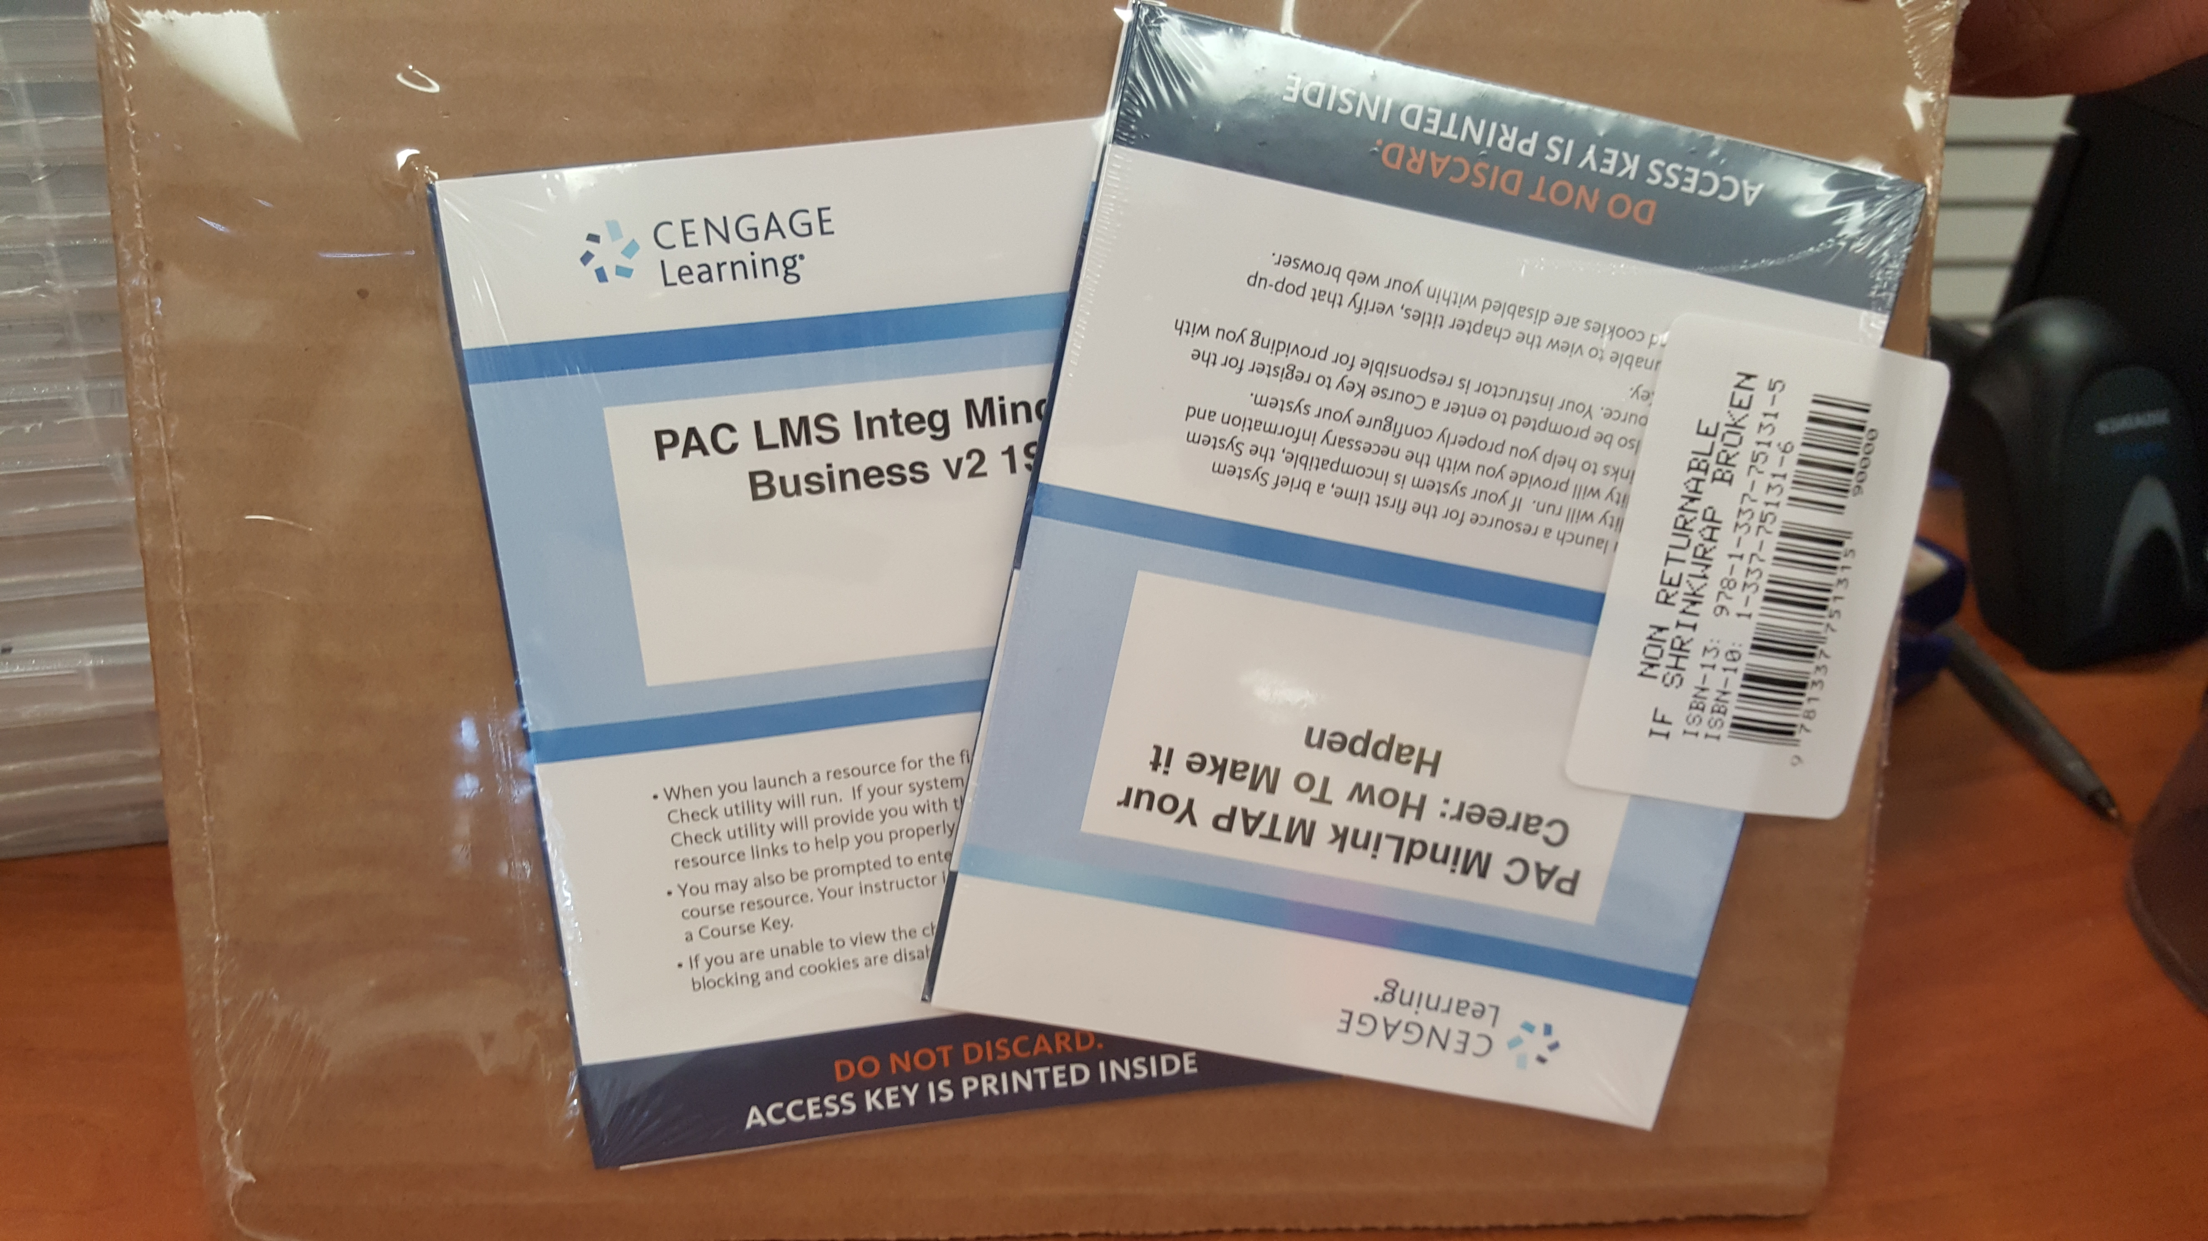

Or you can buy the 2 access codes with E-Books (Digital copy of textbooks) during the first week of class with your own credit card, PayPal, etc. through the below link (costs $147.00) http://services.cengagebrain.com/course/site.html?id=2544645

You MUST have the “Business – Mind Tap access code” and “My Career Success – Mind Tap access code” for this class, as you will complete homework and exam assignments in the “Business” Mindtap website and you will complete different real world business applications in the “Your Career:How to Make it Happen” MindTap website.

- I will contact you as a class through Blackboard (will discuss on first day of class) and also Remind 101 through text message/email.
We will go over Remind 101 as a class during the first class week and sign up for this text service – I will text you often, for important reminders, or if I am ill etc. --

- Class Attendance:
Students are expected to attend all classes in order to be successful in a course. The student may be administratively withdrawn from the course when absences become excessive as defined in the course syllabus.
When an unavoidable reason for class absence arises, such as illness, an official trip authorized by the college or an official activity, the instructor may permit the student to make up work missed. It is the student’s responsibility to complete work missed within a reasonable period of time as determined by the instructor. Students are officially enrolled in all courses for which they pay tuition and fees at the time of registration. Should a student, for any reason, delay in reporting to a class after official enrollment, absences will be attributed to the student from the first class meeting.

Students who enroll in a course but have “Never Attended” by the official census date, as reported by the faculty member, will be administratively dropped by the Office of Admissions and Records. A student who does not meet the attendance requirements of a class as stated in the course syllabus and does not officially withdraw from that course by the official census date of the semester, may be administratively withdrawn from that course and receive a grade of “X” or “F” as determined by the instructor. Instructors are responsible for clearly stating their administrative drop policy in the course syllabus, and it is the student’s responsibility to be aware of that policy.

It is the student’s responsibility to verify administrative drops for excessive absences through MySPC using his or her student online account. If it is determined that a student is awarded financial aid for a class or classes in which the student never attended or participated, the financial aid award will be adjusted in accordance with the classes in which the student did attend/participate and the student will owe any balance resulting from the adjustment.

A student who stops attending class must take the responsibility of contacting the Registrar’s Office to drop the class. If the student fails to do this, the instructor will administratively withdraw the student after two weeks of absences (consecutive or not – on the 5th absence/you are allowed 4 absences)with a grade of “X” or “F”.
Student will be counted absent for an entire class period (after 1 warning) for the following:

- Texting during class
- Instant Messaging during class
- Sleeping during class
- Excessive Tardiness (After 2nd)
- Leaving class early
- Off topic/disruptive, excessive discussion with other students
This classroom is a PROFESSIONAL environment, and I treat it as such. Business students in particular must understand how to conduct themselves in a professional environment. I expect exceptional behavior from ALL of my students! I consider this course to be your job – and I expect behavior to reflect that – if you are late to your job, or turn in work late in the real world, you would be terminated from that job/career – I take on the same assumptions in this course. Please be mindful of the attendance policy, and the “NO LATE WORK ACCEPTED” policy, as I do NOT make ANY exceptions to these rules!

- Assignment Policy: Students are responsible for all class work and notes covered during absences from class with no exceptions. Students are also responsible to be adequately prepared before each class—all reading assignments, cases, etc. If absent, student should contact immediately another student in the class and/or the instructor to receive notes and assignments.
- Grading Policy/Procedure and/or methods of evaluation:
- Chapter Exams (30%): There will be four major chapter exams plus the comprehensive final exam. Each exam will cover both lecture and textbook assignments. Students are responsible for all textbook material assigned and to be prepared to be tested over this material whether or not it is specifically covered during class. The major exams will be announced in advance. NO MAKE-UP EXAMS WILL BE GIVEN.
The final exam will be comprehensive and will either replace the lowest score of the major exams (even if the final exam score is lower) or replace one missed major exam.
A student may be exempt from taking the final exam if no exams have been missed and the student has an “A” average and not more than two absences, or a “B” average and not more than one absence at the end of the semester (the week before Final Exams) . If the student is not exempt from the final and does not take the final exam, student’s final average will be lowered one letter grade.

- ‘Business’ Homework Assignments, Current Event Topics, Quizzes, and Attendance Grades (40%): Assignments will include the following (varying with the chapters): study guides, chapter outlines, questions and cases, team work etc. Due dates for these will be given with each assignment. Most homework will be completed in Mind Tap—instructions for this will be detailed in the first week of class. In class quizzes may be given (there will be no make-up on these). In class attendance grades will be given on a frequent basis to reward those students who are in class. NO MAKE-UP/LATE WORK WILL BE ACCEPTED. If a student misses a daily grade, he/she will be given the grade of a zero; however, one daily grade will be dropped at the end of the semester allowing for an absence. If you miss an attendance grade or any in class assignment, there will be no make-up on these. The only exception is available to students in sponsored SPC athletics or activities. I must have a note from your coach or sponsor!

- Introduction Assignment (during class time) (2.5%)
Introduction during class discussion.

Name
Major
Spare time activities (or if you had spare time, what would you do?)
Favorite class so far and why
Least favorite class so far and why
Business or work area interests or career goals

- Syllabus Summary Assignment (due 1/22/18) (2.5%)
Submit an approximate one-page summary of this syllabus to me using the Blackboard email. Be sure to use the E-Mail feature within Blackboard. The subject line of the email should read “Syllabus summary—Your name”. Do not include in the summary such things as my contact information, etc. that I already know. Include things you feel most important to remember during the semester. This assignment may be keyed in the body of the email or saved as a Word or rich text format file and attached to your email. At the bottom of your summary, please state that you agree to the syllabus guidelines and put the current date by your name.

- Your Career: How to Make it Happen (25%): Specific instructions will be provided during the first week in the semester. This section includes a resume and LinkedIn Profile -

Students are responsible for recording and keeping up with their own grades as work is returned and/or graded in Cengage. Grades will be determined according to the following scale:
90-100 A
80-89 B
70-79 C
60-69 D
Below 60 F
The instructor reserves the right to modify in part or whole this scale to better meet the needs of the individual class.

- Special Requirements: The Teaching & Learning Center located on the third floor of the Levelland campus library provides students free tutoring and study skills information. Call 894-9611 ext. 2241 for help.
- Classroom Requirements: Students will be expected to be on time and in attendance the full 1 hour and 15 minutes of the designated class time. There will be no cell phones or other electronic devices out or turned on in the classroom!

COURSE OUTLINE: Major areas of study –
The Environment of Business
Trends in Business Today
Management and Organization
Human Resources
Marketing
Info. for Business Strategy and Decision Making
Finance and Investment

- ACCOMMODATIONS: EQUAL OPPORTUNITY: South Plains College strives to accommodate the individual needs of all students in order to enhance their opportunities for success in the context of a comprehensive community college setting. It is the policy of South Plains College to offer all educational and employment opportunities without regard to race, color, national origin, religion, gender, disability or age. In this class, the teacher will establish and support an environment that values and nurtures individual and group differences and encourages engagement and interaction. Understanding and respecting multiple experiences and perspectives will serve to challenge and stimulate all of us to learn about others, about the larger world and about ourselves. By promoting diversity and intellectual exchange, we will not only mirror society as it is, but also model society as it should and can be.
SPECIAL SERVICES: Students with disabilities, including but not limited to physical, psychiatric, or learning disabilities, who wish to request accommodations in this class should notify the Disability Services Office early in the semester so that the appropriate arrangements may be made. In accordance with federal law, a student requesting accommodations must provide acceptable documentation of his/her disability to the Disability Services Office. For more information, call or visit the Disability Services Office at Levelland Student Health & Wellness Center 806-716-2577, Reese Center (also covers Lubbock Center) Building 8: 806-716-4675, Plainview Center Main Office: 806-716-4302 or 806-296-9611, or the Health and Wellness main number at 806-716-2529.

- ELECTRONIC ASSIGNMENTS: This class will involve the use of the Internet and some access to discussion groups, forums, bulletin boards, e-mail programs and/or chat rooms in order to complete the objectives of this class. Topics assigned by the instructor will be relevant to the objectives of this course.
DISCLAIMER: “This is to notify you that the materials you may be accessing in chat rooms, bulletin boards or unofficial web pages are not officially sponsored by South Plains College. The United States Constitution rights of free speech apply to all members of our community regardless of the medium used. We disclaim all liability for data, information or opinions expressed in these forums.”

Campus Concealed Carry - Texas Senate Bill - 11 (Government Code 411.2031, et al.) authorizes the carrying of a concealed handgun in South Plains College buildings only by persons who have been issued and are in possession of a Texas License to Carry a Handgun. Qualified law enforcement officers or those who are otherwise authorized to carry a concealed handgun in the State of Texas are also permitted to do so. Pursuant to Penal Code (PC) 46.035 and South Plains College policy, license holders may not carry a concealed handgun in restricted locations. For a list of locations, please refer to the SPC policy at: (http://www.southplainscollege.edu/human_resources/policy_procedure/hhc.php)
Pursuant to PC 46.035, the open carrying of handguns is prohibited on all South Plains College campuses. Report violations to the College Police Department at 806-716-2396 or 9-1-1.

Student Course Learning Outcomes
Student learning Outcome 1: To understand and be able to describe the nature of American business. Upon completion of the course, the student is expected to be able to:
  - Identify and describe the different types of economic systems.
  - Identify the elements of private enterprise and various degrees of competition in the U.S. economic system.
  - Describe how issues of social responsibility and ethics affect business.
  - Explain various aspects of social responsibility such as: economic, socioeconomic, consumerism, employment practices and environmental.
  - Explain the basic for international trading.
  - Discuss trade restrictions between countries.
  - Identify how international businesses are financed.
Student learning Outcome 2: To understand trends in business today. Upon completion of the course, the student is expected to be able to:
- Describe and explain the basic forms of business ownership.
- Identify special types of business ownership.
- Discuss small businesses and entrepreneurship participation in US economy.
- Explain how franchising has increased entrepreneurship in US.
- Explain the basic management functions.
- Identify levels of management and specialization.
- Identify types of managers and leadership styles.
Student learning Outcome 3: To understand the functions of management, organization and human resources.
Upon completion of the course, the student is expected to be able to:
- Explain how organization structures are developed.
- Explain how organization structures are managed
- Identify the different forms of organizational structures.
- Identify and explain key human resource issues such as, recruiting, attracting, staffing, motivating, retaining and employees benefits.
- Discuss some of historical perspectives on motivation...
- Explain how various techniques are employed to motivate employees in the workplace.
Student learning Outcome 4: To understand the basic elements of the marketing concepts. Upon completion of the course, the student is expected to be able to:
- Explain the purpose of a marketing plan.
- Identify and explain marketing concepts such as, product life cycle, branding, packaging and labeling.
- Identify the key elements of promotion and marketing mix.
- Explain ways marketers meet the need of consumers and industrial users.
- Explain how channels of distribution are used to disseminate goods to the marketplace.
Student learning Outcome 5: To understand the concepts of financial management.
Upon completion of the course, the student is expected to be able to:
- Explain the role of accountants in business.
- Explain and describe how basic financial statements are utilized by businesses to make decisions.
- Distinguish between equity and debt financing.
- Discuss the function of the Federal Reserve System.
- Describe different types of financial institutions.

